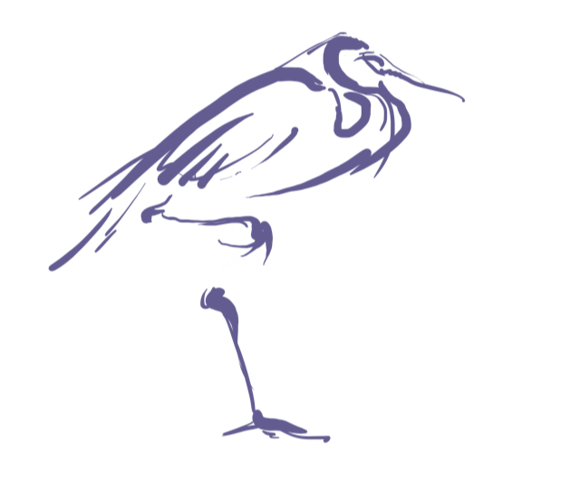
Virginia Association for Elementary and Middle School Principals (VAESP)
Annual Conference
June 26-June 28, 2022
Hilton, Virginia Beach Oceanfront

Call for Proposals

The VAESP invites you to submit a proposal for a concurrent session during our annual statewide conference. Concurrent sessions will be 60 minutes in length.
This year’s theme is Our Time to “SEAS” the Day, Reflect, Respond, Rejuvenate. Presentations will be selected based on the timeliness of the topic, overall interest and well-defined summary of presentation and learning intentions.
Proposals must be received by March 1, 2022. All presenters are expected to register for the conference.
Submit proposal electronically to Karnold@vaesp.org, subject line: Conference Proposal

